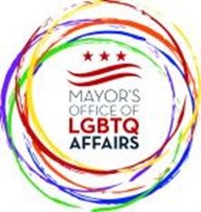

TUESDAY, DECEMBER 6, 2016
Government of the District of Columbia
Advisory Committee to the Mayor’s Office of LGBTQ Affairs

The meeting was called to order at 6:00PM by Chair

- 9 Commissioners were in attendance
  - (Victoria Kirby-York, Kylar Broadus, Ruth Eisenberg, David Perez, Abdur-Rahim Briggs, Bradley Lewis, Leticia Gomez, Jim Slattery, Nicole Armstead),
- 1 Staffer (Sheila Alexander-Reid), no public body members

Agency update

a)Job Fair w/ govt agencies being planned for January,
b) BID for Gay Games 2022 was submitted
c) Despite the fears arising regarding the election of Pres.Trump, DC will continue to support its immigrant, and LGBT residents by remaining a sanctuary city

Old business
a) Budget subcommittee to meet to discuss Mayor's budget (bring ideas for funding priorities... some that have been mentioned so far are: MPD funding for operation of GLLU at night, Trans employment program, Office of aging for LGBT seniors, LGBT Housing), implementation of budget priorities and how resources reach LGBT community through services

New business
a)FY17 new meeting schedule: Feb 7th, May 2nd, June Pride parade, Sept 12th).
b) 2017 meeting topics: revisit aging and youth and discuss new topics
c) To adjust for going from monthly to quarterly meetings, subcommittees can form and meet between meetings to take place as needed

Meeting was adjourned at 7pm

